Day 1:
*Find your spelling words.

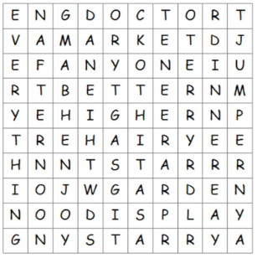

jumper higher star starry
better dinner doctor market
enjoy display afternoon anyone
Day 2:
Write the spelling words in ABC order.

star 1. _____________________ jumper 1. _____________________
higher 2. _____________________ better 2. ________________
starry 3. _____________________ dinner 3. ________________
market 4. _____________________ hairy 4. ________________
doctor 5. _____________________

Day 3:
Add the correct punctuation to each sentence.
- Do you think it is going to rain today____
- Clean your desk before you leave____
- Tim left his jacket at school____
- Put your book bag in your cubby____
- What do you want for lunch____

Divide the words into syllables with a /
1. introduce 2. argument 3. wonderful

Day 4:
Circle the adverbs. Underline the verbs
Circle the adjectives. Underline the nouns
Tell whether the circled word is an adverb or an adjective.

- Tim shared a yummy cookie with me. _____________________
- The turtle walked slowly down the road. _____________________
- Jan spoke softly in the classroom. _____________________
- My dog ate a crunchy bone. _____________________

*Match the vocabulary words.

_____ create a. very short periods of time
_____ dazzling b. meaning or moral in a poem
_____ imagination c. syllables that make rhythm in a line of poetry
_____ seconds d. the ability to create new ideas or images
_____ beats e. to make
_____ message f. bright
_____ metaphor g. compares two unlike things
_____ repeated lines h. some lines used at least twice in a poem

